**For Loops:**

- A *for* keyword indicates the start of a for loop  
- A *temporary variable* that will store the contents of the items being iterated on  
 - Name is arbitrary and can be anything, does not need to be pre-defined  
 - Best practice is to make it as descriptive as possible  
- A *in* keyword separates the temporary variable from the permanent variable  
- A *collection­* of items to loop over  
- An *action* to perform on each iteration of the loop   
 - Needs to be indented within body of *for* loop  
 - Everything at this level or lower will run in every iteration of loop  
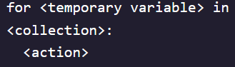 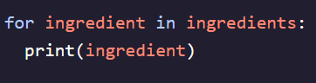

**Using Range:**

- To create arbitrary collections of any length, use built-in function *range()*- Use a variable name ***different*** than the one for the variable being printed - Loop iteration number can be tracked by printing out the *temporary variable* +1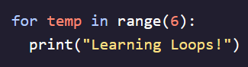 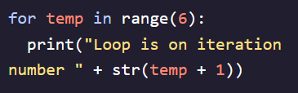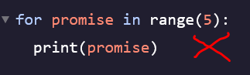 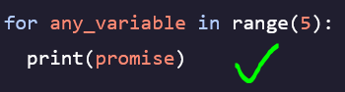

**While Loops:**

- Performs a set of instructions as long as a given condition is true  
- Count remains indented under print because it will execute directly afterwards  
